Graded Problems for Module 5
The graded problems in module 5 involve SELECT statements for multiple tables and row summaries and data manipulation statements using the INSERT, UPDATE, and DELETE statements of SQL. You should execute the statements using either Oracle or MySQL.

SELECT Statement Problems
- For event requests, list the event number, event date (eventrequest.dateheld), and count of the event plans. Only include event requests in the result if the event request has more than one related event plan with a work date in December 2018.
Query:
SELECT EVENTREQUEST.EVENTNO,DATEHELD,
COUNT(PLANNO) AS TOTAL_EVENTS FROM EVENTREQUEST
JOIN EVENTPLAN ON EVENTREQUEST.EVENTNO=EVENTPLAN.EVENTNO WHERE WORKDATE BETWEEN '01-DEC-2018' AND '31-DEC-2018' GROUP BY EVENTREQUEST.EVENTNO,DATEHELD HAVING COUNT(PLANNO)>1;
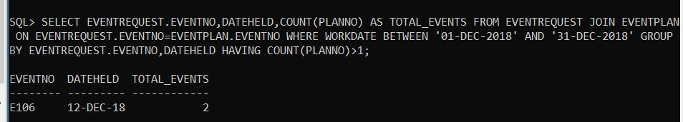

- List the plan number, event number, work date, and activity of event plans meeting the following two conditions: (1) the work date is in December 2018 and (2) the event is held in the “Basketball arena”. Your query must not use the facility number (“F101”) of the basketball arena in the WHERE clause. Instead, you should use a condition on the FacName column for the value of “Basketball arena”.
Query:
SELECT PLANNO,EVENTPLAN.EVENTNO,WORKDATE,ACTIVITY
FROM EVENTPLAN
JOIN EVENTREQUEST ON
EVENTPLAN.EVENTNO=EVENTREQUEST.EVENTNO
JOIN FACILITY ON EVENTREQUEST.FACNO=FACILITY.FACNO
WHERE WORKDATE BETWEEN '01-DEC-2018' AND '31-DEC-2018' AND FACNAME='Basketball arena';

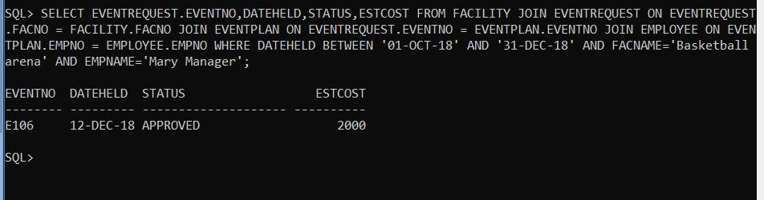

- List the event number, event date, status, and estimated cost of events where there is an event plan managed by Mary Manager and the event is held in the basketball arena in the period October 1 to December 31, 2018. Your query must not use the facility number (“F101”) of the basketball arena or the employee number (“E101”) of “Mary Manager” in the WHERE clause. Thus, the WHERE clause should not have conditions involving the facility number or employee number compared to constant values.
Query:
SELECT EVENTREQUEST.EVENTNO,DATEHELD,STATUS,ESTCOST FROM FACILITY
JOIN EVENTREQUEST ON EVENTREQUEST.FACNO = FACILITY.FACNO
JOIN EVENTPLAN ON EVENTREQUEST.EVENTNO = EVENTPLAN.EVENTNO JOIN EMPLOYEE ON EVENTPLAN.EMPNO = EMPLOYEE.EMPNO
WHERE DATEHELD BETWEEN '01-OCT-18' AND '31-DEC-18' AND FACNAME='Basketball arena' AND EMPNAME='Mary Manager';
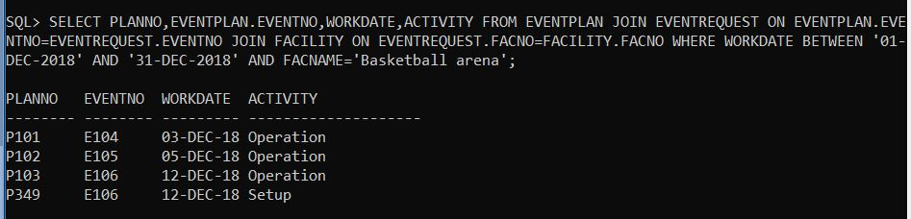

- List the plan number, line number, resource name, number of resources (eventplanline.number), location name, time start, and time end where the event is held at the basketball arena, the event plan has activity of activity of “Operation”, and the event plan has a work date in the period October 1 to December 31, 2018. Your query must not use the facility number (“F101”) of the basketball arena in the WHERE clause. Instead, you should use a condition on the FacName column for the value of “Basketball arena”.
Query:
SELECT EVENTPLANLINE.PLANNO,LINENO,NUMBERFLD,LOCNAME,TIMESTART,
TIMEEND FROM LOCATION
JOIN EVENTPLANLINE ON LOCATION.LOCNO=EVENTPLANLINE.LOCNO JOIN EVENTPLAN ON EVENTPLANLINE.PLANNO = EVENTPLAN.PLANNO JOIN EVENTREQUEST ON EVENTPLAN.EVENTNO = EVENTREQUEST.EVENTNO
JOIN FACILITY ON EVENTREQUEST.FACNO = FACILITY.FACNO
WHERE ACTIVITY='Operation' AND FACNAME='Basketball arena' AND WORKDATE BETWEEN '01-OCT-2018' AND '31-DEC-2018';
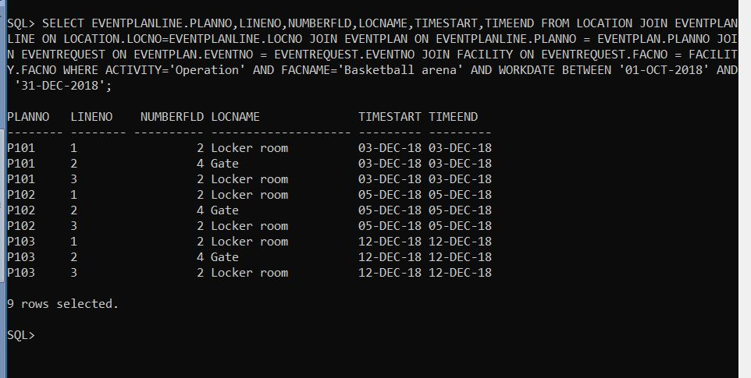

Database Modification Problems
- Insert a new row into the Facility table with facility name “Swimming Pool”.
Query: INSERT INTO FACILITY (FACNO,FACNAME) VALUES ('1234','Swimming Pool');
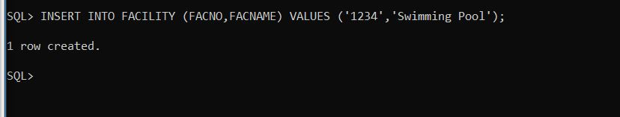
2. Insert a new row in the Location table related to the Facility row in modification problem 1. The new row should have “Door” for the location name.
Query: INSERT INTO LOCATION (LOCNO,FACNO,LOCNAME) VALUES ('686','1234','Door');
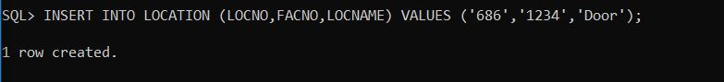
3. Insert a new row in the Location table related to the Facility row in modification problem 1. The new row should have “Locker Room” for the location name.
Query: INSERT INTO LOCATION (LOCNO,FACNO,LOCNAME) VALUES ('687','1234','Locker Room');
4. Change the location name of “Door” to “Gate” for the row inserted in modification problem 2.
Query: UPDATE LOCATION SET LOCNAME='Gate' WHERE LOCNAME='Door';
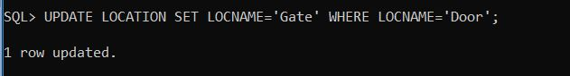
5. Delete the row inserted in modification problem 3.
Answer : DELETE FROM LOCATION WHERE LOCNAME='Locker Room';
